|  |  |  |
| --- | --- | --- |
|  | ***Sahel Journal of Life Sciences FUDMA (SAJOLS)***  **December 2023 Vol. 1(1): 76-88**  **ISSN: 3027-0456 (Print)**  **ISSN: xxxx-xxxx (Online)**  **DOI:** [***https://doi.org/10.33003/sajols-2023-0101-009***](https://doi.org/10.33003/sajols-2023-0101-009)  [**https://saheljls.fudutsinma.edu.ng/index.php/saheljls/article/view/16/version/16**](https://saheljls.fudutsinma.edu.ng/index.php/saheljls/article/view/16/version/16) |  |

***Research Article***

**Evaluation of Antibacterial Activity, Phytochemical Screening and GCMS Analysis of Ethanol and Aqueous Extracts *Adansonia digitata* Fruits (Kuka) Against Some Clinical Isolates**

**Umaru Abdulmalik*, Anas Umar and Ishaq Shehu**

Department of Microbiology, Federal University Dutsin-Ma, Katsina State

*Corresponding Author’s Email: [**umaruabdulmalik449@gmail.com**](mailto:umaruabdulmalik449@gmail.com)Phone:+2347068291559

**Received:** 7th December, 2023 **Accepted:** 27th December, 2023 **Published:** 31st December, 2023

**ABSTRACT**

*Adansonia digitata* plant is a tree with a wide range of medicinal properties used to treat a variety of infectious diseases locally. The main aim of this study is to evaluate the antibacterial activity, phytochemical screening and GCMS analysis of ethanol and aqueous extracts of *Adansonia digitata* fruits against some clinical isolates. The Powdered fruit of *Adansonia digitata* was extracted using the ethanol solvent and distilled water. The extracts component was subjected to Phytochemical screening using standard procedure. The extracts were tested for antibacterial activity against *Staphylococcus aureus* and Escherichia coli, using disc diffusion methods using different concentrations. Gas chromatography mass spectrophotometer analysis was used to quantify the two extracts The results of phytochemical screening indicated the presence of alkaloids, flavonoids, reducing sugars, steroids, saponins, phenols and tannins in both extracts, except tannin that was no dictated in aqueous extract Results of sensitivity test showed that ethanol extracts were more active than aqueous extract on the isolates tested. The extracts also demonstrated antibacterial activities as it showed zone of inhibition against *Staphylococcus aureus* and Escherichia coli. This study showed that distilled water, and ethanol extract were effective against all the test organisms used in this study at the concentrations of 600 mg/ml and 800 mg/ml. The range of zone of inhibition using ethanol extract (10.0 mm – 14.0 mm) was significantly higher than zone of inhibition using aqueous extract (0.00 mm – 6.0 mm). The MIC values the extracts have the potential for the production of drugs against some clinical bacterial isolates.

**Keywords:** *Adansonia digitata;* Clinical Isolates; Extracts Concentrations; Antibacterial

**Citation:** Abdulmalik, U., Umar, A. and Shehu, I. (2023). Evaluation of Antibacterial Activity, Phytochemical Screening and GCMS Analysis of Ethanol and Aqueous Extracts *Adansonia digitata* Fruits (Kuka) Against Some Clinical Isolates. *Sahel Journal of Life Sciences FUDMA*, 1(1): 76-88. DOI: [*https://doi.org/10.33003/sajols-2023-0101-009*](https://doi.org/10.33003/sajols-2023-0101-009)

**INTRODUCTION**

*Adansonia digitata* is indigenous to the African continent and a member of the Bombacaceae family (Halilu and Muhammad, 2023). African baobab also known as dead rat tree, Ethiopian sour gourd, Judas’s bag, lemonade tree, monkey bread tree, monkey tamarind, Senegal calabash, and upside down tree, there are 8 species of *Adansonia* genus (Gebauer and Luedeling, 2013; Sundarambal *et al.,* 2015). It is an indigenous wild fruit tree that is of great importance in arid and semi-arid. Africa, where other fruit species cannot easily be cultivated (Gebauer and Luedeling, 2013; Usman 2004). This enormous tree supposedly has its origin in the African continent and brought in by sailors who came to establish trade links with India Mishra *et al.,* (2019).

The baobab tree is endemic to the areas of South Africa, Botswana, Namibia, Mozambique and other tropical African countries where suitable habitat occurs. It is also found in Pakistan, Sri Lanka and Bangladesh (Sundarambal *et al.,* 2015). According to Mishra *et al*., (2019), it is a curious shaped, medium sized, deciduous tree. Native to tropical Africa, baobab trees are bizarre in appearance with grotesquely swollen trunks the tree is usually massive, with a barrel like trunks. That may reach a diameter of 9 meter; few trees are tall as 25 meter. Baobab generally produce leaves during the rainy season and shed their foliage during the dry season to reduce moisture loss, the tree produces large white flowers these hang down on long stalks. Fruit of the baobab large gourd like with velvety skin also hang down by long stalks. Leaves and fruits are eaten, commonly used as medicine. (Sundarambal *et al.,* 2015). The trees are tolerant to high temperatures and long spans of drought, and are grown for their sour fruit and leaves. The fruit consists of large seeds embedded in a dry, acidic pulp and shell Usman (2004).

Phytochemical investigation revealed the presence of flavonoids, phytosterols, amino acids, fatty acids, vitamins and minerals. It is used in scurvy related diseases, laxative purpose, anti-diabetic, anti-diarrhoeal, anti- trypanosomal activities (Sundarambal *et al.,* 2015). The pulp (fruit) is therapeutically employed as febrifuge, analgesic, anti-diarrhea / anti-dysentery and for treatment of smallpox and measles Vertuani *et al., (*2002). The oil relieves pains from burns and stimulates the formation of new epithelial tissues and is utilized in cosmetics in hair mask for hair care, aiding in the process of dermatoses and sunburn and treatment of Acne vulgaris. (Halilu and Muhammad, 2023). The leaves are used to make soup, and the pulp can also be used as a beverage and in food preparation. Fermented seeds are used as flavoring soups, where the roasted seed is used as a side dish substituting peanut, while the fresh ones are pressed for oil Usman (2004). Every part of the baobab tree (roots, seeds, pulp, flowers, leaves, and bark) is useful to humans (Ofori *et al*., 2023).

The nutritional value of baobab varies depending on where it is grown and what components of the plant are consumed, such as the leaves, pulp and seeds, the pulp, for instance is high in vitamin c, antioxidants, and a number of important minerals such as potassium, magnesium, iron and zinc Rana *et al.,* (2022). According to Yusha’u *et al*., (2010), the fixed oil of *Adansonia digitata* seeds is presently used in cosmetics to restore and moistened the skin due to its penetrating ability and nourishing properties. The oil contains vitamin A and F for rejuvenating and renewal of cell; vitamin E as antioxidant and anti-ageing and it relieves pains from burns and stimulates the formation of new epithelial tissues and is utilized in cosmetics in hair mask for hair care, aiding in the process of treatment of dermatitis, sunburn and treatment of Acne vulgaris (Hudault *et al*., 2001).

The leaves are used to prepare "kuka soup" in Nigeria, where they are referred to as "kuka" locally Yusha'u et al. (2010). During the rainy season the baobab leaves are tender and people harvest the leaves fresh whereas the last month of the rainy season, leaves are harvested in great abundance and are dried for domestic use and for marketing during the dry season. The leaves are typically sun-dried and either stored as whole leaves or pounded and sieved into a fine powder Ojo and Oniyi, (2022). By elucidating the phytochemical composition and antibacterial efficacy of *Adansonia digitata* fruits, this research will contribute to the existing knowledge on natural products with antimicrobial properties. The findings may have significant implications for the development of alternative therapeutic options to combat antibiotic-resistant clinical isolates and enhance public health outcomes.

**MATERIALS AND METHODS**

**Study Area**

The study area of research project was Dutsin-ma, Katsina State. Which lies between the latitude of 12°17.00N' to 12°17.84 and longitude 007°26'E.

**Sample** **Collection and Identification**

*Adansonia digitata* fruit was purchased from Wednesday market, Dutsin-Ma, Katsina state. It was taken to the department of Plant Science and Biotechnology Federal University Dutsinma Katsina. The fresh fruit was dried and pounded.

**Collection of Bacteria Isolates**

The test bacteria (*Staphylococcus aureus,* and *Escherichia coli)* were the clinical isolates used. There were collected from Federal University Dutsin-ma Clinic, Katsina State.: The collected bacterial isolates were sub-cultured in an agar slants and stored at 4°C until time of use.

**Identification of Isolates**

The isolated bacterial organisms were identified through the following biochemical test;

***Catalase Test***: 2ml of hydrogen peroxide solution was poured into a test tube, isolated colonies of the bacterial was immersed into the hydrogen peroxide solution and was observed for immediate bubbling or not.

***Indole Test****:* 4ml of tryptophan broth was poured in a sterile test tube and the isolated colonies of the bacterial was inoculated and incubated at 37°C for 24h. And 0.5ml of kovac's reagent was added to the broth culture and the presence or absence of ring was observed.

***Methyl Red Test****:* Pure culture of the bacterial were inoculated into the MRVP (Methyl red Voges-Proskauer) broth and incubated at 35°-37°C for a minimum of 48 hours in ambient air. 5 to 6 drops of methyl red reagent per 5ml of broth were added and color change was observed in the broth medium.

***Gram Staining*:** Using a sterile wire loop, a loopful of colony of microorganisms was collected and fixed on a sterile glass slide and smeared then allowed to air dry. It was then gently flooded with crystal violet, tilting the slide and allowed to stand for 60seconds then rinsed with water and then blot dried. The smear was gently flooded with grams iodine and again allowed for 60seconds then rinsed with water. Acetone was used to decolorize the slide, and immediately flushed with water. It was finally flooded with safranin and allowed to stand for 45seconds then rinsed. Then it was blot dry and viewed under the light microscope under x100 oil immersion.

**Phytochemical Screening of *Adansonia digitata* Fruits Extract**

The phytochemical analysis of the crude aqueous extract of *Adansonia digitata* were conducted to determine whether certain constituents, such as flavonoids, tannins, glycoside, saponins, and alkaloids, were present using standard methods of analysis (Trease and Evans, 2002).

***Test for Alkaloids***

A few drops of Drgendoff's reagent were added to a fraction of the extract. Alkaloids are indicated by a reddish-brown precipitate (Trease and Evans, 2002).

***Test for Flavonoids***

A small amount of the extract was mixed with a few drops of 10% sodium hydroxide. Flavonoids are indicated by yellow coloring (Trease and Evans, 2002).

***Test for Tannins***

Three drops of ferric chloride solution were added to a portion of the extract. Condensed tannins are represented by a greenish black precipitate, whereas hydrolyzable tannins produce a blue or brownish-blue precipitate (Trease and Evans, 2002).

***Test for Glycosides***

The crude extract (1cm³) was measured into a sterile test tube and 5cm³ of 5% H2SO4 was added. The mixture was heated for 10 minutes. It was removed from the source of heat and Sem³ of Fehling’s solution was added and boiled. A brick red precipitate was observed which indicate the presence of cardiac glycosides (Trease and Evans, 2002).

***Test for Saponins***

The crude extract (1cm³) was mixed with distilled water and was shaked vigorously in a test tube for 30 seconds. Frothing was formed which persisted upon warming thereby confirming the presence of saponins (Trease and Evans, 2002).

***Test for Phenols***

To 2 ml of extract, 3 ml of ethanol and a pinch of ferric chloride are added. A greenish yellow color appeared which indicates the presence of Phenols

***Test for Terpenoids***

Acetic anhydride test: To 2 ml of extract, 2 ml of acetic anhydride and concentrated SULPHURIC

ACID was added. Formation of blue, green rings indicate the presence of terpenoids

**Preparation of Culture Media**

The method of WHO (2008) was adopted foe the preparation of nutrient agar. The prepared media was used for antimicrobial assay. (World Health Organization, 2008).

**Preparation of McFarland Standard**

McFarland standard suspensions of bacterial isolates were prepared in accordance to the methods of WHO (2008). These preparations were thereafter used as inoculums for antimicrobial assay (World Health Organization, 2008).

**Ethanol Extraction**

The *Adansonia digitata fruits* crude ethanolextracts were prepared in accordance to the method of Abubakar (2009). These extracts were thereafter used for the sensitivity test and other antimicrobial assay (Abubakar, 2009).

**Aqueous Extraction**

The *Adansonia digitata fruits* crude aqueousextracts were prepared in accordance to the method of Abubakar (2009). These extracts were thereafter used for the sensitivity test and other antimicrobial assay (Abubakar, 2009).

**Preparation of Extract Concentration and Stock Solutions**

The concentrated extracts were dissolved in DMSO to prepare stock solutions of known and variable concentrations. Various test concentrations were prepared from ethanol and aqueous crude extract in accordance with the dilution method describe by Baker *et al.,* (1993) Stock solutions of the each of the extracts of petroleum ether, ethanol and aqueous were prepared by dissolving one gram (1g) of the extract in a bijou bottle containing 1ml of Dimethyl Sulfoxide (DMSO) to give 100,000mg/ml solution and labeled as the stock solution. The working solutions were prepared from the stock solution. From the stock solution 0.4ml was transferred to a bijou bottle containing 0.6ml of DMSO, 0.6m to 0.4ml of DMSO, 0.8ml to 0.2ml of DMSO and 1ml this gave a concentration of 400mg/ml, 600mg/ml, 800mg/ml and 1000mg/ml respectively to which 0.1ml of each concentration of was transfer to the hole.

**AGAR Well Diffusion Method Screening**

Screening the antibacterial activity will be performed using agar cup diffusion method Saced *et al.,* (2005). Muller Hinton agar plates will be flooded with 0.1ml of the standardized inoculums of bacteria. The inoculums was spread evenly over plate with rile glass spreader. The flooded plates were allowed to dry in the incubator at for 20 minutes. A standard cork borer of 6mm diameter were used to cut uniform wells on the surface of the plates and 0.1 ml of each concentration 200mg/ml, 400mg/ml. 600mg/ml, 800mg/ml and Streptomycin (control) was introduced into the wells. The inoculated plates were incubated at 37°C for 24 hours and zone of inhibition diameter was measured to nearest millimeter (mm).

**Determination of the Minimum Inhibitory Concentrations (MIC)**

The MICs of the extract was determined using the method described by Akinpelu and Kolawole (2004), 2ml of different concentrations of the *Adansonia digitata* extract was added to 18ml of pre-sterilized molten nutrient agar at 40°C. The medium was then poured into petri dishes and allowed to set. The surface of the media was allowed to dry before streaking with 24 hours old bacteria isolate. The plates were incubated in an incubator at 37°C for up to 24 hours after which the MIC was taken as the lowest concentration that prevented the growth of the test bacteria isolates.

**Determination of Minimum Bactericidal Concentration (MBC)**

By inoculating the contents of each test tube onto a nutrient agar plate, the minimum bactericidal concentration was ascertained using the broth dilution test results from the MIC tubes, as previously mentioned. The plates were incubated for 24 hours at 37°C; Olaley et al. (2007) noticed that the lowest concentration of the extract that did not result in any growth was likewise recorded as the minimum bactericidal concentration.

**Gas Chromatography Mass Spectrometry Analysis (GCMS)**

At the NARICT laboratory in Zaria, Nigeria, ethanol and aqueous extracts of Adansonia digitata fruit was analyzed using Gas Chromatography-Mass Spectrometry (GC-MS) utilizing a GC-MS QP2010 PLUS Shimadzu, Japan instrument. A total of 40.8 mL/min, 49.2cm/sec linear velocity, 1.80 mL/min column flow, 3.0 ml/min purge flow, 250.0 oC injector temperature, 2.0 min hold time, and carrier gas were all off. The ethanol and aqueous extracts of Adansonia digitata fruits were analyzed using Gas Chromatography-Mass Spectrometry (GC-MS) with a GC-MS (Model: QP 2010 series, Shimadzu, Japan) fitted with a VF-5ms fused silica capillary column, which has a 30m length, 0.25mm diameter, and 0.25μm film thickness. Ionization: The temperature of the column oven was programmed to range from 80°C to 280°C for 2°C min-1.

**RESULTS**

Findings of this study, as presented in Table 1 shows the result of the phytochemical compounds in the aqueous and ethanol extract of *Adansonia digitata* (Baobab fruits) revealing the presence of alkaloids, flavonoids, terpenoids, phenols, glycosides, tannins, saponins in all extracts with only the aqueous extract that tested negative for tannins.

Also in Table 2, it shows the zone of inhibition of *S. aureus* and *E.coli* against both the aqueous and ethanolic extract of *Adansonia digitata* fruits at different concentrations. The aqueous extract have the highest activity of 14 mm at the concentration of 600 mg/ml for *E. coli* while the 10 mm zone of inhibition was recorded at the concentration of 600 mg/ml against *S. aureus.* The control zone of inhibition where 28 mm, 28 mm and 30 mm where recorded.

The ethanolic extract of *S. aureus* at the concentration of 200 mg/ml and 600 mg/ml possess activity that range between 7 mm and 10 mm in the ethanolic extracts. Also the ethanolic extract of *E. coli* at the concentration of 200 mg/ml and 600 mg/ml possess activity in which 8 mm is the least and 20 mm in the ethanolic extracts with the *E.coli* have high antibacterial activity. The control zone of inhibition where 14 mm, 18 mm and 19 mm where recorded.

Table 3 shows the minimum inhibitory concentration (MIC) of ethanolic extract against *S. aureus* which is 50 mg/ml and against *E. coli* which is 25 mg/ml. In contrast, the minimum inhibitory concentration (MIC) of aqueous extract against *S. aureus* is 100mg/ml and that of *E. coli* is 50 mg/ml.

Table 4 shows the result of the Minimum bactericidal concentration (MBC) of ethanol and aqueous extract against both *S. aureus* and *E. coli.* The MBC of ethanol extracts against the both test organisms is 50 mg/ml. The MBC of aqueous extract against *S. aureus* is 100 mg/ml and that of *E. coli* is 50 mg/ml.

Table 5 Shows Phytocomponent identified from aqueous extract of *Adansonia digitata* fruits by GCMS Analysis the retention time (RT), molecular formular, molecular weight (MW), area % and compound name were presented. The GC-MS analysis identified total number of eighteen (18) compounds as follows: Undecen, 1 butanol, Benzaldehyde, resorcinol, alpha-D-Glucopyranoside, 3-O-Methyl-d-glucose, Hexadecanoic acid, 9,12-Octadecadienoic acid, 11-Octadecanoic acid, Phytol, Oleic Acid, 1,2-Cyclooctanediol, 2- Octylclopropen c-1-heptanol, 1,5-Cyclododecadiene, Acetaminde, Hexadecanoic aci, 9,12-Octadecadienoylchloride and Squalene.

Table 6 Shows the Phytocomponent identified from ethanol extract of from *Adansonia digitata* fruits by GCMS Analysis the retention time (RT), molecular formular, molecular weight (MW), area % and compound name were presented. The GC-MS analysis identified total number of seven (7) compounds as fellows: Octadecenamide, Eicosanoid acid, Hexadecanoic acid, 9- Octadecenamide, Decyl oleate, 9-Tetradecenal and 6-Octadecenoic acid.

**Table 1: Phytochemical screening of ethanolic and aqueous extract of *Adansonia digitata* fruit**

|  |  |  |
| --- | --- | --- |
| **Phytochemical Compound** | **Ethanol** | **Aqueous** |
| Alkaloids | + | + |
| Flavonoids | + | + |
| Terpenoids | + | + |
| Phenols | + | + |
| Glycosides | + | + |
| Tannins | + | - |
| Saponins | + | + |

**Key**: (+) Positive, (-) negative

**Table 2.** Zone of inhibition of *S. aureus* and *E. coli* against Aqueous and Ethanol extracts

|  |  |  |  |  |  |  |  |  |  |  |  |  |  |  |  |  |  |  |  |
| --- | --- | --- | --- | --- | --- | --- | --- | --- | --- | --- | --- | --- | --- | --- | --- | --- | --- | --- | --- |
| **Test organism** | | ***S. aureus*** | | | | | | | ***E.coli*** | | | | | | | | | | |
| Sample concentration mg/ml | | 200 | | 400 | | 600 | 800 | Control (mm) | 200 | 400 | | 600 | | 800 | | Control (mm) | | | |
| 1a | | 0.00 | | 0.00 | | 0.00 | 0.00 | 0.00 | 6.0 | 6.0 | | 9.0 | | 0.0 | | 28.0 | | | |
| 2a | | 0.00 | | 0.00 | | 0.00 | 0.00 | 0.00 | 6.0 | 6.0 | | 6.0 | | 9.0 | | 30.0 | | | |
| 3a | | 0.00 | | 0.0 | 0.00 | 0.00 | 0.00 | 6.0 | | 6.0 | | 6.0 | | 6.0 | | 28.0 |  |
| 1b | | 0.00 | | 0.8 | 10.0 | 8.00 | 0.00 | 11.0 | | 12.0 | | 14.0 | | 11.0 | | 19.0 |  |
| 2b | | 0.0 0 | | 0.7 | 8.00 | 8.00 | 0.00 | 10.0 | | 12.0 | | 20.0 | | 11 .0 | | 18.0 |  |
| 3b | | 7.00 | | 7.0 | 10.0 | 0.00 | 0.00 | 8.00 | | 9.00 | | 12.0 | | 10.0 | | 14.0 |  |

**Key:**

1a, 2a and 3a –Aqueous extracts

1b, 2b and 3b –Ethanolic extracts

**Table 3.** Minimum inhibitory concentration of the extracts against test organisms in mg/ml

|  |  |  |
| --- | --- | --- |
| **Extract** | ***S. aureus*** | ***E. coli*** |
| Ethanol | 50 | 25 |
| Aqueous | 100 | 50 |

**Table 4.** Minimum bactericidal concentration of the extracts against the test organisms (mg/ml)

|  |  |  |
| --- | --- | --- |
| **Extract** | ***S. aureus*** | ***E. coli*** |
| Ethanol | 50 | 5o |
| Aqueous | 100 | 50 |

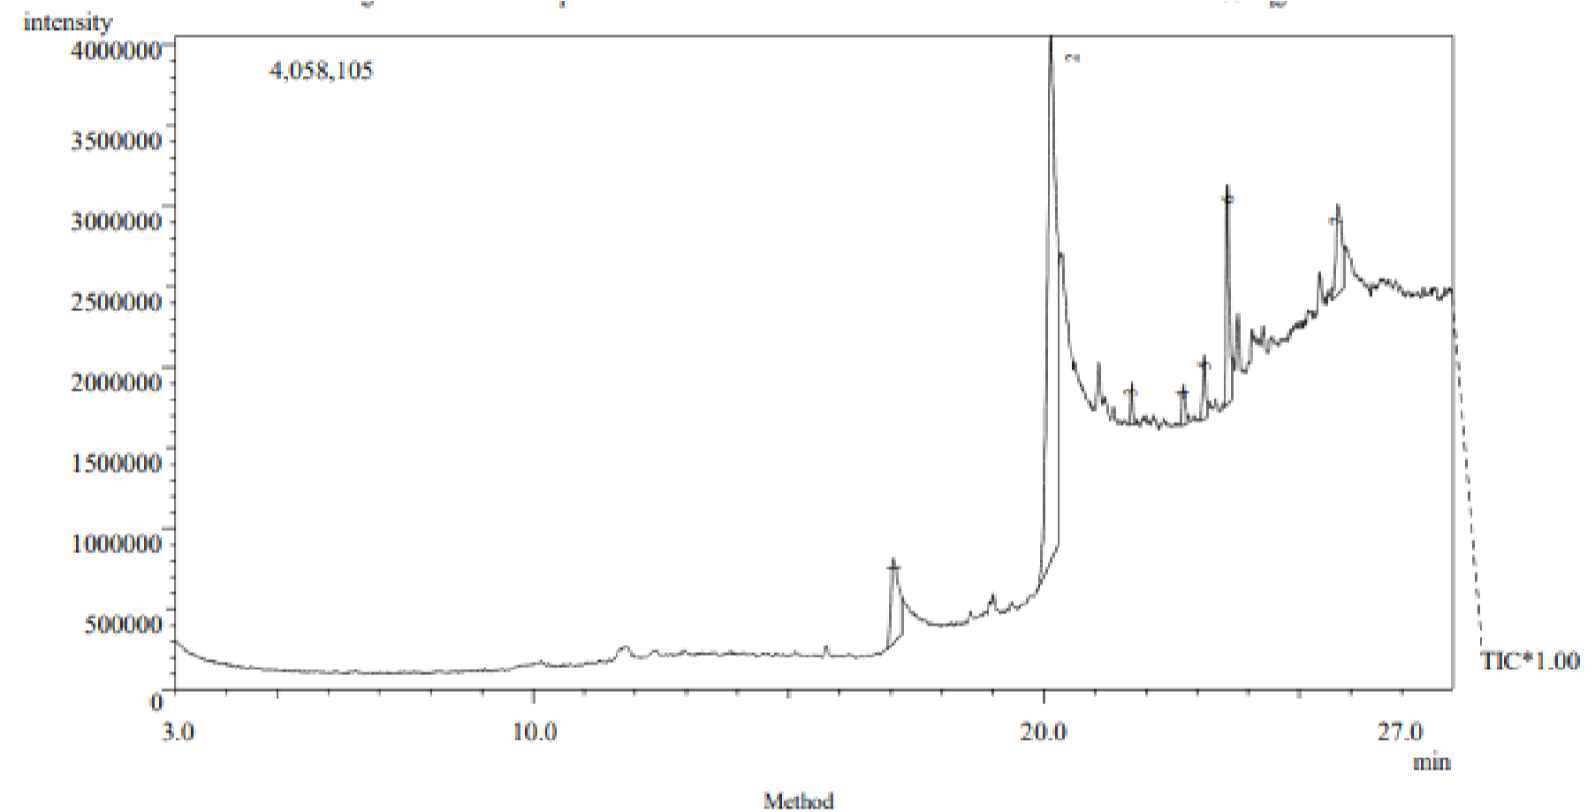

**Figure 1**. Chromatogram of *Adansonia digitata* Aqueous Fruit Extract

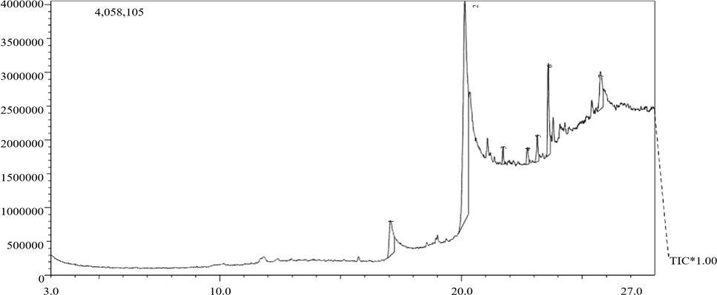

**Figure 2.** Chromatogram of *Adansonia digitata* Ethanol Fruit Extract

**Table 5.** Phytochemical Components identified from aqueous fruits extract of *Adansonia digitata* by GC-MS Analysis

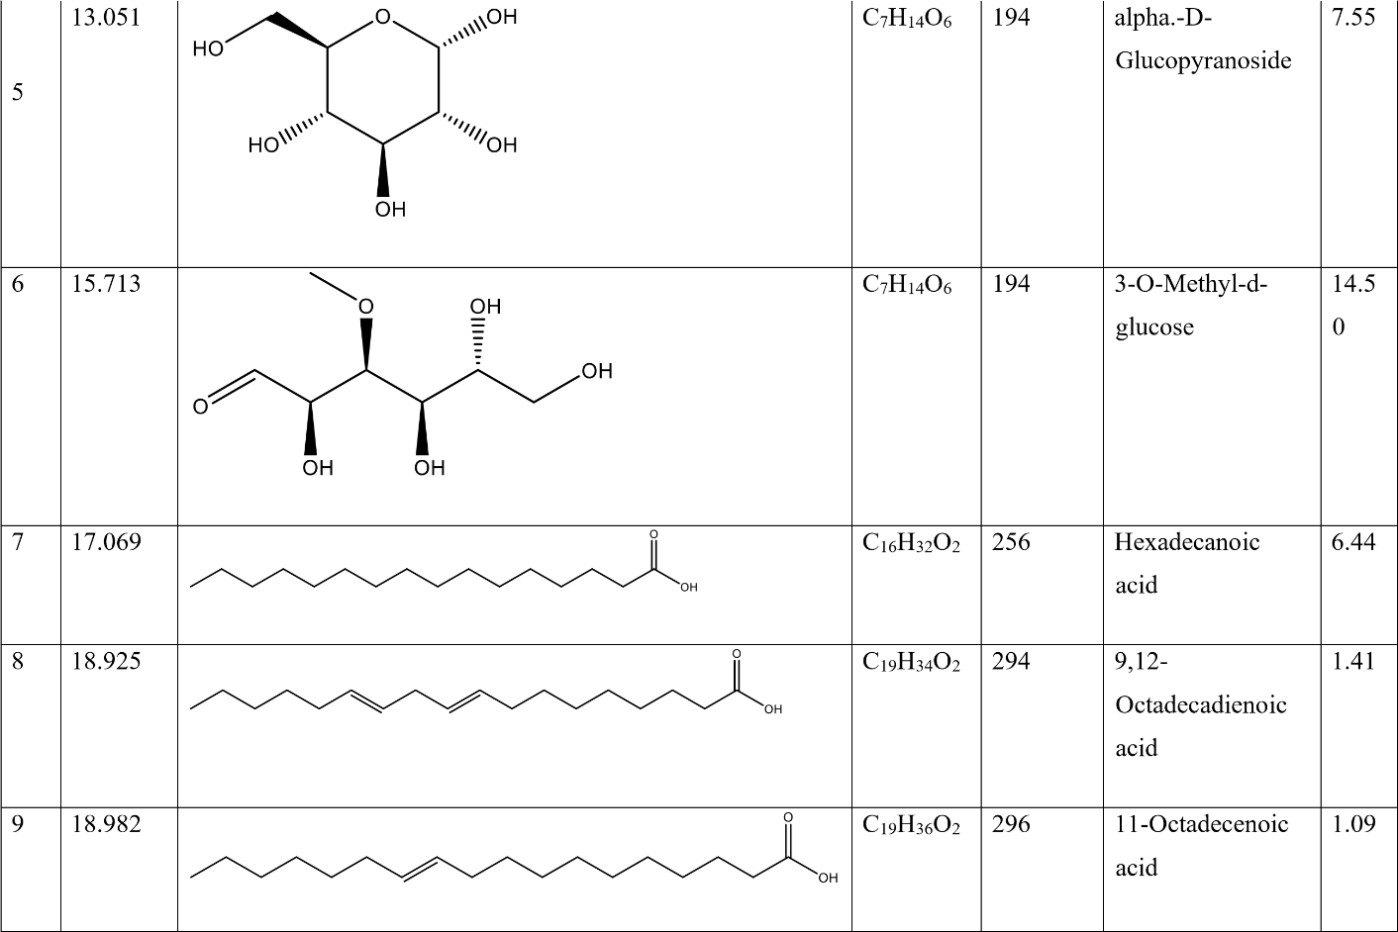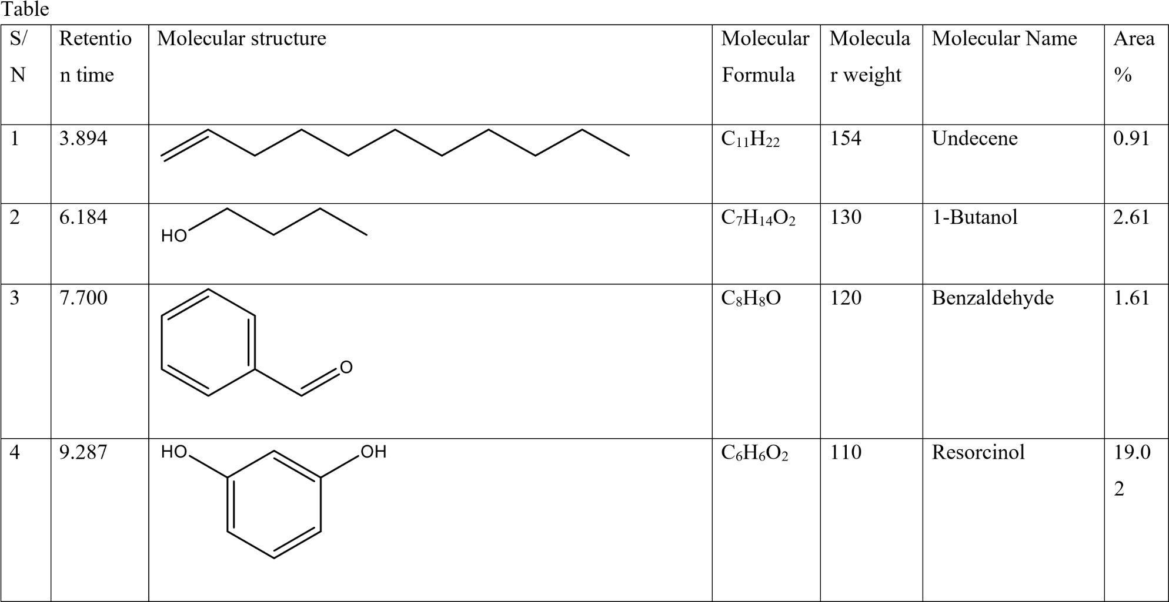

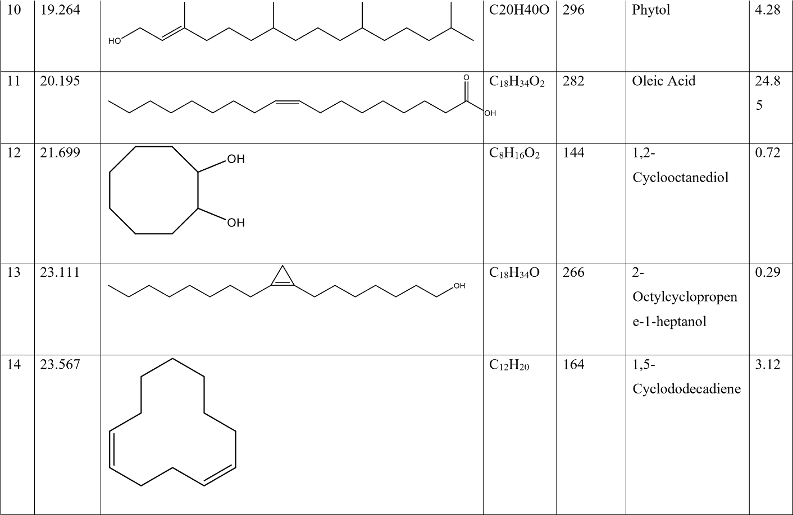

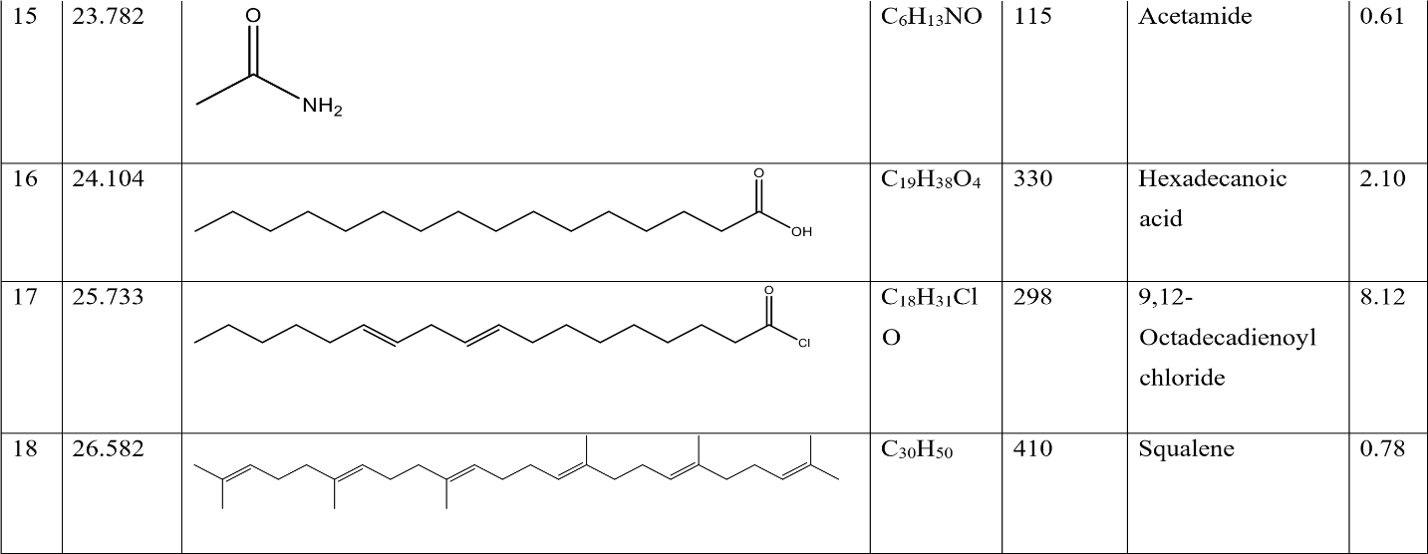

**Table 6**. Phytochemical constituent identify by ethanol Leaf extract of *Adansonia digitata*

|  |  |  |  |  |  |  |  |  |  |  |
| --- | --- | --- | --- | --- | --- | --- | --- | --- | --- | --- |
| S/N | Retention time | Molecular structure | | | | | Molecular  Formula | Molecular weight | Molecular  Name | Area  % |
| 1 | 17.053 |  | | | | | C20H40O2 | 312 | Eicosanoid acid | 9.45 |
| 2 | 20.134 |  |  |  | | | :C18H34O2 | 282 | Octadecenamide | 66.50 |
|
|
| 3 | 21.718 |  |  |  | | | C35H68O5 | 568 | Hexadecanoic acid | 1.48 |
|
|
| 4 | 22.730 |  | |  | | | C18H35NO | 281 | 9-  Octadecenamide | 2.03 |
|  |  |  |
|  |
| 5 | 23.135 |  | | | | | C28H54O2 | 422 | Decyl oleate | 2.80 |
| 6 | 23.587 |  | | | | | C14H26O | 210 | 9-Tetradecenal | 9.79 |

**DISCUSSION**

The plant parts mostly used include the seeds, leaves, bark, oil and root. Phytochemical such as alkaloid, saponins, flavonoids, tannins and terpenoids are chemical bioactive components responsible for antibacterial activities in the plant. The presence of bioactive compounds such as flavonoids in plants indicates the presence of naturally occurring phenolic compound with beneficial effect in the human diet as an antioxidant that neutralized free radicals. Compaoré *et al.,* (2011) has shown that flavonoids, proanthocyanidins and phenolic compounds are present in the fruit of *Adansoni digitata* which make it a good radical scavenger. Elsewhere the fruits of *Adansonia digitata* have been reported to contain proanthocyanidins as the major compounds (Shahat, 2006). Triterpenes, alkaloids, anthraquinones, saponins, tannins have also been reported to be present in the fruit pulp of *A. digitata* (Ramadan *et al.,* 1994: Gbadamosi *et al.,* 2011) which also in line with this studies. The findings also agreed with the report of Tanko *et al.* (2008) also revealed the presence of tannins, carbohydrate, terpenes, saponins, flavonoids and alkaloids present in *Adansonia* *digitata.* In other studies VanStaden *et al.*, (2011). Tuani *et al*., (1997) found several classes of compounds including flavonoids, glycosides, and tannins

Ethanolic extract of *Adansonia digitata* fruit in this study had higher solubility for more bioactive compounds than aqueous extracts; this consequently account for its higher antibacterial activity. However, this is consistent to the finding of Bashir *et al.,* (2022), where they demonstrated that ethanolic extract having higher solubility for more bioactive compounds thus, having the highest antibacterial activity. The activity of this extracts may be related to the presences of tannins and flavournoids that are present and reported to be responsible for the antimicrobial properties of some ethno medicinal plants (Singh and Bhat, 2003)

The aqueous extracts showed no zone of inhibition against *S. aureus* at the concentration of 200 mg/mL, 400 mg/mL, 600 mg/mL and 800 mg/mL. However it showed higher activity at the concentration of 600 mg/mL and 800 mg/mL against *E.coli*. No zone of inhibition was found when the extract was tested against *Staphylococcus aureus.* In contrast to *Staphylococcus aureus,* zones of inhibition were found when the extract was tested against the different strains of *Escherichia coli*. This is contrast to the work of (Bashir *et al.,* 2022).

In contrast to aqueous extract, ethanolic extract exhibit higher activity against *S. aureus* at the concentration of 200 mg/mL, and 800 mg/mL. The ethanolic extract concentrations (200 mg/mL, 400 mg/mL, 600 mg/mL, and 800 mg/mL) against *E.coli* have high antibacterial activity but the highest of all being the concentration of the extract at 800 mg/mL is more soluble and more antibacterial. This agree with Yagoub (2008), that, showed that the petroleum ether, ethanol and aqueous extracts of baobab showed antimicrobial activity against *Escherichia coli..* The ethanolic fruit extract had much activity against all the test organisms with 800 mg/mL concentration having the highest activity followed by 600 mg/mL concentration of the extract. This low antibacterial activity shown by the aqueous extracts may be an indication that the active compound(s) were poorly extracted. This outcome is similar to those observed by Bashir *et al.,* (2022). The findings of the study demonstrated that fruit extracts of *A. digitata* have much more activity against the test organisms only at higher concentration (600 mg/mL and 800 mg/mL). It was observed (Table 3) in this research that, antibacterial activity of the extracts was enhanced by an increase in the concentration increases of the extracts, this correspond with the work of (Mann *et al* 2008) i.e. the higher the concentration of the plant extract the greater the zones of inhibition.

The minimum inhibitory concentration (MIC) of ethanolic extract against *S. aureus* which is 50 mg/.ml and against *E. coli* which is 25 mg/.ml. In contrast, the minimum inhibitory concentration (MIC) of aqueous extract against *S. aureus* is as high as 100 mg/.ml and that of *E. coli* is 50 mg/.ml. The Minimum bactericidal concentration (MBC) of ethanolic and aqueous extract against both *S. aureus* and *E.coli* is 50 mg/.ml The MBC of aqueous extract against *S. aureus* is 100 and that of *E.coli* is 50 mg/.ml which is contrary to the findings of (Bashir *et al.,* 2022).

The MIC obtained showed that both ethanolic and aqueous fruit extracts were very active even at average concentration against the test organisms and this supports the findings of other researchers like Bashir *et al.,* (2022). However, ethanolic extract is even more effective than the aqueous extract because it inhibited the growth of the test organisms at a concentration of 25 mg/mL which is lower than 50 mg/mL concentration inhibited by aqueous extracts. Hence, the ethanolic and aqueous extracts inhibited all the test organisms (*S. aureus and E. coli)* at concentrations ranging from 25 to 100 mg/ml.

The MBC showed that the ethanolic extracts eliminated *E. coli* at 50 mg/mL corresponding to aqueous extracts which also eliminated *E. coli* at 50 mg/ml. *Staphylococcus aureus* was only destroyed when the aqueous extracts concentration reached 100 mg/ml. Hence, the ethanolic extracts are more effective than the aqueous extracts. The minimum bactericidal concentration obtained in the study indicated that fruit extracts of *A. digitata* plants are very active even at average concentrations especially when ethanol solvents is used for extraction. The MIC values obtained in this research were lower than that of MBC, this reveals that the concentration used in this research was only be able to inhibit the organisms rather than killing them. i.e. Bacteriostatic at lower concentration and bactericidal at higher concentration, this correspond with the work of (Abalaka *et al* 2008).

The result of phytochemical components identified from aqueous extract by GC-MS Analysis showed the retention time (RT), molecular formular, molecular weight (MW), area percentage (%) and compound names. It revealed eighteen (18) compounds (Table 6). Phytochemical components identified from ethanol extract by GC-MS Analysis showed the retention time (RT), molecular formular, molecular weight (MW), area percentage (%) and compound name. The GC-MS analysis revealed seven compounds (7) (Table 7). The identified compounds possess many biological properties. For instance Phytol Diterpene is an antimicrobial, anticancer, antiinflammatory and diuretic agent (Praveen *et al.,* 2010). Similarly Maria *et al.,* (2011) observed the presence of phytol in the leaves of Lantana camara and Sridharan *et al.,* (2011) in *Mimosa pudica* leaves. Similar result was also observed in the leaves of Lantana camara (Sathish and Manimegalai, 2008) which agreed with the finding of this study.

Phytol was observed to have antibacterial activities against *Staphylococcus aureus* by causing damage to cell membranes as a result there is a leakage of potassium ions from bacterial cells which is reported by Inoue *et al.,* 2005. Hexadenoic acid has earlier been reported as a component in alcohol extract of the leaves of Kigelia pinnata (Grace et al., 2002) and Melissa officinalis (Sharafzadeh *et al.,* 2011). Parasuraman *et al.,* (2009) who identified 17 compounds with n-Hexadecanoic acid and Octadecanoic acid as the major compounds in the leaves of Cleistanthus collinus which is also similar to the finding of this study.

GC-MS analysis of ethyl acetate extract of Goniothalamus umbrosus revealed the presence of n-Hexadecanoic acid reported by Siddiq *et al.,* (2009). N-hexadecanoic acid, Hexadecanoic acid, Phytol, 9, 12 - Octadecadienoic acid, 9, 12, 15-Octadecatrienoic acid and Squalene were identified in leaf extract of Aloe Vera which is also reported Arunkumar and Muthuselvam, (2009) and Vitex negundo (Praveen *et al.,* 2010). Squalene is used in cosmetics as a natural moisturizer. Devi *et al.,* (2009) reported that Euphorbia longan leaves mainly contained hexadecanoic acid and 9, 12-Octadecadienoic acid. These reports are in accordance with the result of this study.

**CONCLUSION**

Based on the findings of this research work, it is concluded that *Adansonia digitata* fruit extracts contain bioactive constituents which are responsible for the antibacterial activity of the crude extracts. And this also showed that *Adansonia digitata* fruit present a potential for production of drugs used in the treatment of infections caused by *Staphylococcus* *aureus* and *Escherichia coli.*

*Adansonia digitata* could be taken alongside some synthetic drugs depending on the severity of the illness during the treatment of diseases caused by *S. aureus* and *E. coli.* Also, ethanol should be the best solvent when it comes to extraction of *A. digitata* fruit due to its ability to extract more of the chemical compounds present than water. In view of these findings, it is recommended that efforts should be made to investigate the antimicrobial activity and toxicity of this plant *in vivo*.

**REFERENCES**

Abubakar, E. M. (2009): Efficacy of Crude Extracts *of Adansonia digitata* against Nosocomial Escherichia coli. *Staphylococcus aureus*, *Streptococcus pneumoniae* and *Pseudomonas aeruginosa*. *Journal of Medicinal Plants Research.* Vol. **3**(6):179-185

Abalaka.M.EDaniya S. And Mann A. (2010). Evaluation of the antimicrobial of two *ziziphus species* (*Z*. *Mauritania* and *Z.spinachristii*) on some microbialpathoges. *African journal of pharmacology and pharmacy.* Vol. 4(4) pp 135-139 April 2010.

Arunkumar S and Muthuselvam M: 2009. Analysis of Phytochemical constituents and antimicrobial activities of Aloe vera L. against clinical pathogens. *World J. Agricultural Sci*., **5**(5): 572-576

Bashir, M., Ibrahim, A., Bilyaminu, M., Ali, R., Isa, H., Sambo, K.H., Ishaq, I. (2022). Phytochemical screening and antibacterial activity of leaf and stem bark extracts of *Adansonia* digitata on *E.coli, S. aureus* and *S. typhi*. Microbes and Infectious Diseases. Vol. **3**(1): 217-223.

Chambers, H.F. (2005): Community- Associated MRSA Resistance and Virulence. *England Journal of Medicine.***352** (14): 1485-1487.

Croxen, M. A., Law, R. J., Scholz, R., Keeney. K. M., Wlodarska, M., Finlay, B. B. (2013). Recent Advances in Understanding Enteric Pathogenic *Escherichia coli.* Clinical 880 Microbiology Reviews. **26** (4); 822-80.

Compaoré, W.R., Nikièma, P.A., Bassolé, H.I.N., Savadogo, A., Mouecoucou, J.,Hounhouigan, D.J, Traoré, S.A. (2011). Chemical Composition and Antioxidative Properties of Seeds of Moringa oleifera and Pulps of *Parkia biglobosa and Adansonia digitata* Commonly used in Food Fortification in Burkina Faso. *Current Research Journal of Biological Sciences*, **3**(1), 64-72.

Devi P, Nagarajan M, Christina AJM, Meera R and Merlin NJ (2009): GC-MS analysis of Euphorbia longan leaves. *Int. J. of Pharmaceutical Res and Development*; **8**: 1-4.

Fabiyi, O.A. (2022).Cytotoxicity and Nematicidal Potential of Leaf Extracts of *Adansonia digitata* and *Khaya senegalensis* on Root Knot Nematode (*Meloidogyne incognita*) Associated with Cabbage. *The Journal of Agricultural*. Vol. **17**(3): 425-436.

Gebauer, J., Luedeling, E. (2012). A note on baobab (*Adansonia digitata* L.) in Kordofan, Sudan. Genetic Resour Crop Evolution. Vol. **60**: 1587- 1596.

Grace OM, Light ME, Lindsey KL, Moholland DA, Staden JV and Jader AK (2002: Antibacterial activity and isolation of antibacterial compounds from fruit of the traditional African medicinal plant, Kigelia africana. *S.Afr.J.Bot*; ***68***: 220-222.

Gbadamosi, I.T., Moody J. O., Lawal, A. M. (2011). Phytochemical screening and proximate analysis of eight ethnobotanicals used as antimalaria remedies in Ibadan. *Nigeria Journal of Applied Biosciences,***44**, 2967 – 2971

Halilu, E.M., Muhammad, N.K. (2023). [Physicochemical and free radical scavenging activity of*Adansonia digitata* seed oil.](https://www.researchgate.net/publication/370491454_Physicochemical_and_free_radical_scavenging_activity_of_Adansonia_digitata_seed_oil?enrichId=rgreq-866c1266bb64bc88f30823f61dfcae9e-XXX&enrichSource=Y292ZXJQYWdlOzM3MDQ5MTQ1NDtBUzoxMTQzMTI4MTE1Njc3MTk5OEAxNjgzNjE4MDQ2OTk5&el=1_x_3&_esc=publicationCoverPdf)Physical Sciences Vol. **5**(7): 1-16.

Hudault, S., Guignot, J., Servin, A. L. (July 2001). *Escherichia coli* Strains Colonising. The Gastrointestinal Tract Protect Germ Free Mice against *Salmonella typhimurium* Infection.Gut. Vol. **49** (1): 47-55.

Inoue Y, Hada TA, Shiraishi K, Hirore, H Hamashima and Kobayashi S (2005): Biphasic effects of Geranylgeraniol, Terpenone and Phytol on the growth of *Staphylococcus aureus*. Antimicrobial agents and Chemother; **49**(5): 1770- 1774.

Lim, J. Y., Yoon, J., Hovde, C. J. (2010). A brief overview of *Escherichia coli* 0157:7 and its plasmid 0157. *Journal of Microbiology and Biotechnology.* Vol. **20** (1): 5-14.

Maria jancy rani P, Kannan PSM and Kumaravel S: GC-MS Analysis of Lantana camara L. Leaves. JPRD 2011; **2**(11): 63-66.

Mishra, R.K., Marde, R., Joshi, B., Srivastava, A., Joshi, S. (2019). Review on *Adansonia digitata* L. (Gorakshi): A historical and endangered tree species in India. *International Journal of Unani and Integrative Medicine*. Vol. **3**(2): 1-4.

Mann A. Yahaya Y. and Boson G. O (2008). Phytochemical and antibacterial screening of *annogeissus leiocarpus* against some microorganism associated with infectious wound. *African journal of microbiology Research* vol. (**2**) pp 060-062.

Ofori, H., Addo, A., Dzisi, K.A., Bart-Plange, O. (2023). A review of baobab (*Adansonia digitata*) fruit processing as a catalyst for enhancing wealth and food security. *Journal of the Ghana Institution of Engineering*. Vol. **23**(2) 35-43

Olaleye, M.T., Adegboye, O.O., Akindahunsi, A.A. (2007): Alchorneacordifolia Extract Protects Wister Rats against Acetaminophen Induced Liver Damage. *African Journal Bioteclology*. Vol. **5**(8): 2439-2445.

Ojo, R.O., Oniyi, S.O., (2022). The Antimicrobial Activities of Crude Extracts of Fruits of *Adansonia digitata. Achievers Journal of Scientific Research.*Vol**4**(1): 86-94.

Osman, M. (2004). Chemical and Nutrient Analysis of Baobab (*Adansonia digitata*) fruit and seed protein solubility. Plant Foods for Human Nutrition. Vol**59**: 29-33.

Praveen kumar P, Kumaravel S and Lalitha C: Screening of antioxidant activity, total phenolics and GC-MS study of Vitexnegundo. *Afr. J. Biochemistry Res* 2010; **4** (7): 191-195.

Parasuraman S, Raveendran R and Madhavrao C (2009): GC MS analysis of leaf extracts of Cleistanthus collinusoxb. (Euphorbiaceae). *Int. J. Ph. Sci*; **1**(2):284-286.

Rabi’u, U., Sa’idu, H., Labaran, H.S., Olanrewaju, S.A., Muntari, M., Ibrahim, S.I. (2020). Phytochemical Screening and Antibacterial Activity of Stem Bark of Baobab Tree (*Adansonia digitata*) on some clinical isolate. *Journal of Biochemistry, Microbiology and Biotechnology*. Vol. **8**(2): 21-15.

Rana, H., Kumar, R., Chopra, A., Pundir, S., Gautam, G.K., Kumar, G. (2022). The Various Pharmacological Activity of *Adansonia Digitata*. *Research Journal of Pharmacology and Pharmacodynamics Vol 14(1): 1-8.*

Rufa’i, M.S., Shamsudden, U., Usman, A.D. (2022). Toxicity Studies of Ethanolic Leaf Extract of *Adansonia Digitata*. *Bayero Journal of Pure and Applied Sciences.* Vol. **13**(1): 478484.

Ramadan, A., Harraz, F.M., EL-Mougy, S.A.,(1994). Anti-inflamatory, analgesic and antipyretic effects of the fruit pulp of *Adansonia digitata,*Fitoterapia, **65**(5), 418-422

Sridharan S, Meenaa V, Kavitha V and Agnel Arul John Nayagam: GC-MS study and phytochemical profiling of Mimosa pudica Linn. *J.Pharm. Res* 2011; **4**(3): 741-742.

Sathish kumar M and Manimegalai S: Evaluation of larvicidal effect of Lantana camara Linn against mosquito species Aedesaegypti and Culexquinque fasciatus. *Advances in Biologi Res* 2008; **2**(3-4): 39-43.

Siddiq Ibraham A, Ahmad Bustamam A, Manal Mohammed E, Syam MI Mohamed Yousif senegalensis *international journal of pharmacology*. **56**: 215-219.

Shahat, A.A., 2006, Procyanidins from *Adansonia digitata*. *Journal of Pharmaceutical Biology,* **44**(6), 445–450

Sharafzadeh S, Morteza Khosh-Khui and Javidnia K. (2011). Aroma Profile of Leaf and Stem of Lemon Balm (Melissa Officinalis L.) Grown under Greenhouse Conditions. *Advan. Environmental Biol,* 5(4): 547-550.

Sundarambal M., Muthusamy, P., Radha R., Jerad S.A. (2015). A review on *Adansonia digitata* Linn. *Journal of Pharmacognosy and Phytochemistry.* Vol. **4**(4): 12-16.

Singh B. and Bhat T.K (2003): Potential therapeutic application of some antinutritio: Plant secondary metabolites. *Journal of Agric. Food Chem*.**51**:5579-5597.

Tony, S. Y., Davis, J. S., Berger, E., Holland, T. L., Fowler, V. G. (2015). *Staphylococcus aureus* - Infections. Epidemiology, Pathophysiology, Clinical Manifestations and Management. Clinical Microbiology. Vol. **28**(3): 603-610.

Trease, G. E. and Evans, W.C. (2002): Phytochemical in Pharmacognosy*. Journal of plants and Phytology.* Vol. **2**(5): 45-76.

Vertuani, S., Braccioli, E., Buzzoni, V., Manfredini, S. (2002).  Antioxidant capacity of *Adansonia digitata* fruit pulp and leaves. *Science and pharmaceuticals*Vol**3**(2): 13-21.

VanStaden, J, Mulaudzi, R.B., Ndhlala, A.R., Kulkarni, M.G., Finnie, J.F. (2012). Antiinflammatory Preferences of Savanna Trees in Burkina Faso. Economic Botany, **57** (2): 203-217.

Vogt, R.L., Dippold, L. (2005). *Escherichia coli* 0157:H17 Outbreak Associated With Consumption Of Ground Beef. Public Health Reports. Vol. **120** (2): 174-8.

World Health Organization, (2002): WHO Traditional Medicine Strategy 2002-2005. Geneva.

World health organization (2008): Fact Sheet on Traditional Medicine. No. 134

Yusha’u, M., Hamza, M.M., Abdullahi, N. (2010). Antibacterial activity of *Adansonia digitata* stem bark extracts on some clinical bacterial isolates. *International Journal of Biomedical and Health Science*s. Vol. **6**(3): 129-135.

Tanko, Y., Yerima, M., Mahdi, M.A., Yaro, A.H., Musa, K.Y. and A. Mohammed, Hypoglycemic activity of methanolic stem bark of *Adansonia digitata* extract on blood glucose levels of streptozocin-induced diabetic wistar rats, *International Journal of Applied Research in Natural Products*, **1**(2) (2008), 32-.36