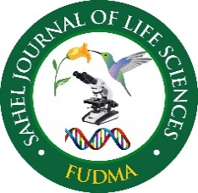 | Sahel Journal of Life Sciences FUDMA (SAJOLS)  September 2026 Vol. 4(3): 281-289  ISSN: 3027-0456 (Print)  ISSN: 1595-5915 (Online)  DOI: https://doi.org/10.33003/sajols-2026-0403-29 | 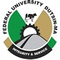
Research Article
Comparative Phytochemical Composition and In-Vitro Antioxidant Properties of Hydroethanolic Extract of Acanthus montanus, Alafia barteri, Aspilia africana, and Boerhavia diffusa Leaves
*Abdulazeez, A. T., Lambe, M. O., Ibitoye, O. B., Oladimeji B. A., and Olalere, Z. T.
Department of Biological Sciences, Al-Hikmah University, Ilorin, Kwara State, Nigeria
*Corresponding Author’s email: azeemahtitilola@alhikmah.edu.ng
ABSTRACT
Growing worries about the limitations of synthetic antioxidants and high cost have heightened the search for natural alternatives from medicinal plants. The investigation examined the phytochemical makeup and in vitro antioxidant effects of hydroethanolic extracts of Acanthus montanus, Alafia barteri, Aspilia africana, and Boerhavia diffusa leaves, four species extensively employed in traditional medicine in North Central Nigeria. Qualitative phytochemical analysis showed that all extracts contained flavonoids, phenols, tannins, cardiac glycosides, alkaloids, and saponins. Quantitative results demonstrated that tannins and cardiac glycosides were the predominant compounds, especially in B. diffusa and A. montanus, whereas flavonoid concentrations were relatively lower. Antioxidant activity was evaluated with DPPH, ABTS, and ferric reducing antioxidant power (FRAP) assays. Alafia barteri, with an IC₅₀ of 44.36µg/ml, 7.5 µg/ml for ABTS and DPPH radical scavenging activity, and 1.6 mMol/ Fe^{2+/}g ferric reducing capacity, was the lowest among all tested extracts, translating to the best antioxidant capacity. All extracts displayed concentration-dependent radical-scavenging and reducing actions, with B. diffusa showing the greatest potency in all tests, followed by A. montanus; A. barteri presented moderate activity, while A. africana exhibited the lowest antioxidant potential. The robust antioxidant performance of B. diffusa was linked to its elevated phenolic and flavonoid levels, highlighting the pivotal role of these phytochemicals in redox modulation. These results offer scientific support for the ethnomedical applications of the examined plants. Additional research encompassing compound isolation, toxicity profiling, and in vivo assessments is recommended to further develop them into therapeutic or nutraceutical agents for diseases linked to oxidative stress.
Keywords: Free radicals; Hydroethanol; Leaves; Oxidative stress; Secondary metabolites
Citation: Abdulazeez, A.T., Lambe, M.O., Ibitoye, O.B., Oladimeji, B.A., & Olalere, Z.T. (2026). Comparative Phytochemical Composition and In-Vitro Antioxidant Properties of Hydroethanolic Extract of Acanthus montanus, Alafia barteri, Aspilia africana, and Boerhavia diffusa Leaves. Sahel Journal of Life Sciences FUDMA, 4(3): 281-289. DOI: https://doi.org/10.33003/sajols-2026-0403-29
INTRODUCTION
Plants employed in traditional healing possess a broad spectrum of compounds capable of addressing both chronic and infectious ailments (Latif and Nawas, 2026). Extensive expertise on applying these plants to various diseases is likely to have gathered in regions where plant usage remains highly significant (Ssenku et al., 2023). Plants produce an extensive array of chemical substances that can be categorized by chemical class, biosynthetic source, and functional groups into primary and secondary metabolites. For millennia, plants have served as traditional medicine. They function as herbal remedies for treating illnesses affecting all population groups worldwide (Ali et al., 2021). The global market for herbal medicine—encompassing products and raw materials—has been projected to grow annually by 5 to 15%. Therefore, it is crucial to link ethno‑pharmacological knowledge with modern drug‑discovery technologies and scientific research to uncover novel active natural metabolites (Allamsetty et al., 2020).
By definition, calling herbal medicines ‘traditional’ suggests considerable past usage, which indeed applies to numerous items marketed as ‘traditional herbal medicines’ (Barrales-Curreno et al., 2019). Across numerous developing nations, a significant share of people depends on traditional healers and their stock of medicinal plants to fulfill health‑care requirements (Pandey et al., 2020). Even though modern medicine can coexist with these traditional approaches, herbal remedies have retained their appeal due to historical and cultural factors (Izah et al., 2024) These items have increasingly entered the commercial market, particularly in affluent nations. In certain nations, herbal medicines are held to strict production standards, but this is not the case worldwide. In Germany, for instance, herbal items marketed as ‘phytomedicines’ must meet specific efficacy, safety and quality requirements similar to those applied to other pharmaceuticals. Conversely, in the USA the majority of herbal goods available commercially are classified and overseen as dietary supplements, a category that does not mandate pre‑market approval based on such standards (Bano et al., 2022). More than 75 % of people in developing regions depend on traditional herbal cures to satisfy their basic health‑care needs. Herbal concoctions are offered in large markets, transport hubs and health stores. They appear as herbal teas and bitters, bottled liquid formulas, capsules, sealed powdered plant material, and fresh plant parts (Krochmal-Marczak et al., 2025).
In biological systems, reactive oxygen species (ROS) and reactive nitrogen species (RNS) such as superoxide, hydroxyl, and nitric‑oxide radicals can injure DNA and cause oxidation of cellular lipids and proteins (Jomova et al., 2023). Typically, the antioxidant mechanisms in the human body neutralize these radicals, maintaining the equilibrium between oxidation and anti-oxidation (Xie et al., 2024). However, exposure to cigarette smoke, alcohol, radiation, or environmental pollutants triggers overproduction of ROS and RNS, upsetting the oxidative–anti-oxidative balance and leading to various chronic and degenerative illnesses (Fakhri et al., 2025). Increasing the consumption of external antioxidants can mitigate oxidative‑stress damage by blocking the start or spread of oxidative chain reactions, acting as free‑radical scavengers, singlet‑oxygen quenchers, and reducing agents (Engwa et al., 2022). When present in excess, free radicals and oxidants generate a condition known as oxidative stress; this detrimental process can impair numerous cellular components, including membranes, lipids, proteins, lipoproteins, and deoxyribonucleic acid (DNA) (Sadiq, 2023). Oxidative stress occurs when the formation of free radicals outpaces the cell’s ability to eliminate them. For example, an overabundance of hydroxyl radicals and peroxynitrite can initiate lipid peroxidation, harming cell membranes and lipoproteins. Consequently, malondialdehyde (MDA) and conjugated diene compounds are produced, which are both cytotoxic and mutagenic. Because lipid peroxidation is a radical chain reaction, it rapidly propagates, affecting a vast number of lipid molecules (Valgimigli, 2023). Proteins can also be compromised by oxidative stress, undergoing conformational changes that may result in loss or reduction of enzymatic activity (Chaudhary et al., 2023).
Exogenous antioxidants primarily come from edible and therapeutic plants, including fruits, vegetables, grains, mushrooms, drinks, blossoms, spices, and conventional medicinal herbs (Jomova et al., 2023). In addition, agricultural residues generated during industrial processing can serve as valuable sources of natural antioxidants (Bano et al., 2022). The plant‑derived natural antioxidants consist chiefly of polyphenols (phenolic acids, flavonoids, anthocyanins, lignans, and stilbenes), carotenoids (xanthophylls and carotenes), and vitamins (Vitamins E and C) (Bano et al., 2022). Overall, these natural antioxidants, particularly polyphenols and carotenoids display numerous biological activities, including anti‑inflammatory, antibacterial, antiviral, anti‑aging, and anticancer effects (Saad et al., 2025). Acanthus montanus is popular in southern Nigeria where it is variously called Elele-nyijuo, Agamsoso and Agameru. Aspilia. africana is referred to as wild sunflower in English, Ewe yun yun in Yoruba, Tozalin in Hausa and Orangila in Igbo. Boerhavia diffusa is commonly referred to as red spiderling in English and Ewe Olowo jeja in Yoruba. Alafia barteri is called Agbari etu in Yoruba. The plants have various uses in ethnomedicine such as the treatment of sickle cell anaemia, rheumatism, eye infections, toothache and wounds. This study aims to compare these medicinal plants in order to assess their respective abilities to provide an effective and sustainable natural source of antioxidants.
MATERIALS AND METHODS
Sample Collection
Leaves of Acanthus montanus, Alafia barteri, Aspilia africana and Boerhavia diffusa were collected from the Oja TunTun local market in Ilorin, Kwara State. Upon collection, they were botanically identified by a plant taxonomist at the Department of Botany, University of Ilorin, Nigeria. Voucher sample were deposited as Acanthus montanus (UILH/004/1090), Alafia barteri (UILH/004/1176), Aspilia Africana (UILH/003/669) and Boerhavia diffusa (UILH/002/909).
Plant Extraction
The leaves were cleaned under running water and air‑dried in the laboratory for one week, then milled into a powder using a blender. The powdered leaves (100 g) were immersed in 1500 ml of 70 % absolute hydro‑ethanol for 72 hours with intermittent shaking every 4 hrs. The extracts were filtered and concentrated to dryness using a rotary evaporator. The resulting dry extracts was kept in an airtight container at 4 °C in the refrigerator for further analysis.
Phytochemical screening of plants
Qualitative phytochemical analysis was done following the method of Trease and Evans (2002). The total flavonoids content of the crude extract was determined by aluminum chloride colorimetric method as described by Piyanete et al. (2009), total phenols content was determined using Folin- Ciocalteu reagent following a slightly modified method of Ainsworth and Gillespie (2007), total saponins content was determined by the method described by Moja et al. (2003) based on vanillin-sulphuric acid colorimetric reaction, total alkaloids content (TAC) of the crude extracts was determined according to the method described by Adegoke et al. (2010), tannins content as described by Makkar et al.(2007), and cardiac glycosides using the method of Elhag et al., 2002.
Determination of antioxidant activity
DPPH (2,2‑Diphenyl‑1‑2 picrylhydrazyl) Test
The determination followed the procedure outlined by Braca et al. (2003).
ABTS (2,2′-azino-bis (3-ethylbenzothiazoline-6-sulfonic acid) Test
The overall antioxidant capacity of the extracts was measured according to the procedure outlined by Hsu et al. (2011).
Ferric reducing antioxidant power assay (FRAP)
The ferric reducing capacity of the extracts was assayed using the method of Benzie and Strain, (1996).
Data Analysis
All experiments were carried out in triplicate, and the results are presented as mean ± standard deviation.
RESULTS
Quantitative phytochemical composition
Table 1 displays the concentration of phytochemicals/secondary metabolites in hydroethanolic extract of the four plants. Tannins and cardiac glycosides occur in greater amounts in all plants, flavonoids are found in smaller amounts in but B. diffusa has the highest concentration. All plants have almost equal concentration of phenols while the highest concentration of tannins is found in A. montanus.
Antioxidant Properties
ABTS radical scavenging activity
The findings of this study showed that the plants displayed a consistent concentration‑dependent rise in the percent inhibition of ABTS. Alafia barteri leaf extract possesses the lowest IC₅₀ among the extracts. (Figure 1 A and B).
DPPH Antioxidant Effect
The result as shown in Figure 2 indicates that A. barteri is the most potent against DPPH radical with an IC50 of 7.40 µg/ml.

Table 1: Secondary Metabolites Present in Hydroethanolic extract of of Acanthus montanus, Alafia barteri, Aspilia africana and Boerhavia diffusa leaves
Sample | Flavonoids | Phenols | Tannins | Cardiac glycoside |  | Alkaloids | Saponins
mg/mL
A. Africana | 4.61 ± 0.03 | 43.57 ± 0.01 | 122.63 ± 0.06 |  | 125.37 ± 0.23 | 66.70 ± 0.11 | 51.46 ± 0.18
B. diffusa | 7.97 ± 0.01 | 48.99 ± 0.01 | 322.41 ± 0.02 |  | 112.24 ± 0.09 | 79.65 ± 0.29 | 69.69 ± 0.08
A. montanus | 6.14 ± 6.62 | 48.02 ± 5.32 | 316.00 ± 3.19 |  | 181.19 ± 0.82 | 370.91 ± 1.21 | 169.74 ± 1.17
A. barteri | 7.93 ± 1.40 | 46.41 ± 2.16 | 303.00± 3.32 |  | 137.70 ± 3.51 | 65.44 ± 2.08 | 92.91 ± 6.76
Values are mean of 3 replicates ± SD

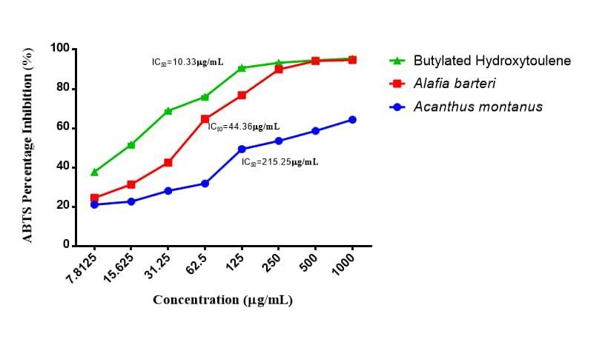
A
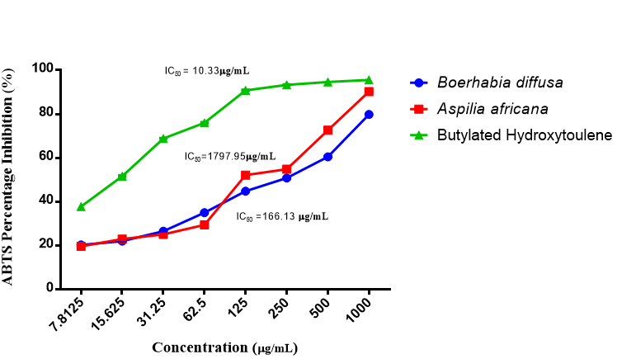

Figure 1: Total antioxidant activity using ABTS•+ radical cation decolorization assay by (A) Alafia barteri and Acanthus montanus (B) Boerhavia diffusa and Aspilia africana

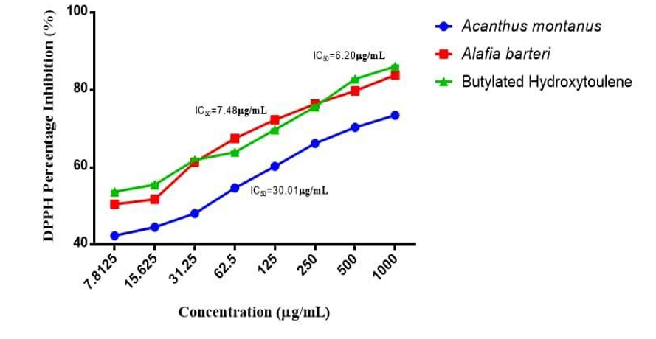
A
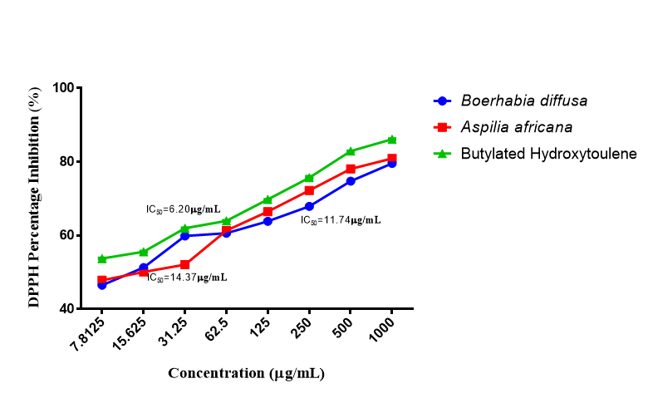
B
Figure 2 DPPH radical scavenging assay of (A) Alafia barteri and Acanthus montanus (B) Boerhavia diffusa and Aspilia africana
Figure 3 shows the ferric reducing capacity of the plant extracts. Although all the plant extract shows considerable ability of reducing ferric to ferrous, they are all significantly lower to the standard (BHT) reducing ability.
Table 2 shows a comparison of the antioxidant properties of the four extract samples. Although, all extracts showed antioxidant capacity, A. barteri is the most potent of all the samples tested.

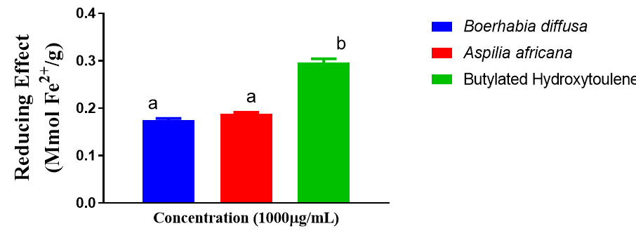
A

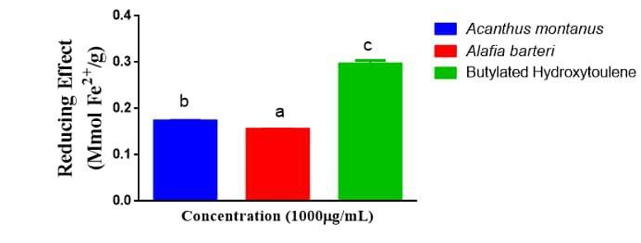
B
Figure 3: Reducing power activity of (A) Alafia barteri and Acanthus montanus (B) Boerhavia diffusa and Aspilia africana
Table 2: Comparison of antioxidant properties of A. Africana B. diffusa A. montanus and A. barteri
Plants | ABTS IC50 (µg/ml) | DPPH IC50 (µg/ml) | FRAP Reducing effect (mMol/ Fe2+/g)
A. Africana | 1797.95 | 14.37 | 0.18
B. diffusa | 166.13 | 11.74 | 0.19
A. montanus | 215.25 | 30.01 | 0.16
A. barteri | 44.36 | 7.48 | 0.16
Standard (BHT) | 10.33 | 6.20 | 0.30

DISCUSSION
This research examined the phytochemical makeup and antioxidant effects of hydroethanolic extracts from four medicinal species frequently employed in North Central Nigeria: Acanthus montanus, Alafia barteri, Aspilia africana, and Boerhavia diffusa. Both qualitative and quantitative phytochemical assessments showed that each of the four plants contain flavonoids, phenols, tannins, cardiac glycosides, alkaloids, and saponins, although their relative amounts differed. The extracts' antioxidant potential was subsequently evaluated through three commonly employed tests: DPPH radical scavenging, ABTS radical scavenging, and ferric reducing antioxidant power (FRAP). These are especially significant in light of the increasing worldwide focus on plant‑based natural antioxidants as safer, more affordable substitutes for synthetic compounds.
Phytochemical analysis showed that the examined Acanthus montanus, Alafia barteri, Aspilia africana, and Boerhavia diffusa hydroethanolic leaves extracts possessed significant quantities of tannins, phenols, flavonoids, alkaloids, saponins, and cardiac glycosides. Quantitative assessment indicated that tannins (322.41 ± 0.02 mg/mL) and cardiac glycosides (181.19 ± 0.82 mg/mL) were among the most plentiful phytochemical groups, particularly in Boerhavia diffusa, A. barteri and Acanthus montanus. In contrast, flavonoid levels were comparatively lower in all species, although B. diffusa (7.97 ± 0.01mg/mL) and A. barteri (7.93 ± 1.40 mg/mL) displayed higher amounts than A. africana (4.61 ± 0.03 mg/mL) and A. montanus (6.14 ± 6.62 mg/mL). This pattern of phytochemical distribution aligns with earlier research that emphasizes the prevalence of polyphenolic substances in medicinal plants historically employed to combat oxidative‑stress‑related disorders (Pattaluchetty et al., 2025; Latif and Nawaz, 2026)
Phenolic substances, such as tannins and flavonoids, are well known for their capacity to donate hydrogen atoms or electrons, thereby scavenging free radicals before they can injure essential cellular constituents like lipids, proteins, and nucleic acids (Oluwole et al., 2022). The elevated phenolic (48.99 ± 0.01 mg/mL) and tannin (322.41 ± 0.02 mg/mL) levels detected in B. diffusa align with its stronger antioxidant activity observed in all tests of this investigation. Plant antioxidant capability is attributable to phenols and tannins contents; their hydroxyl groups donate electrons to neutralize dangerous free radicals (Semiz et al., 2018). Thus, increased antioxidant activity observed is significantly correlated with larger amounts of phenolic and tannins. Likewise, the comparatively high alkaloid content in A. montanus (370.91 ± 1.21 mg/mL) indicates further bioactivity, since alkaloids are recognized not only for antioxidant effects but also for antimicrobial, anti‑inflammatory, and anticancer actions (Owuama, 2017). The detection of saponins in every extract also reinforces their medicinal value, as saponins have been linked to cholesterol reduction, immune modulation, and liver‑protective effects (Naz et al., 2020). Cardiac glycosides, traditionally tied to heart benefits, are increasingly acknowledged for possible cytotoxic and antioxidant activities, further highlighting the importance of these results.
The DPPH assay is commonly employed to assess the hydrogen‑donating capacity of antioxidants, offering insight into their ability to stabilize free radicals. The findings indicated that all four extracts showed scavenging activity that increased with concentration. However, A. bateri displayed the highest activity, with B. diffusa close behind. A. montanus and A. africana exhibited relatively lower radical‑scavenging power as shown in the Table 2. Notably, although none of the extracts reached the effectiveness of the synthetic antioxidant butylated hydroxytoluene (BHT), their performance points to a strong natural antioxidant capability that could be safer for prolonged use.
The ABTS test augments DPPH by evaluating how antioxidants suppress the ABTS⁺ cation radical, which dissolves in both water‑based and lipid environments, thus offering a more comprehensive gauge of antioxidant capacity. The plants exhibited dose‑dependent rises in ABTS scavenging, with A. barteri presenting the lowest IC50, reflecting greater potency relative to others.
The FRAP test evaluates how antioxidants can convert Fe3⁺ into Fe2⁺, indicating their electron‑donating capacity and redox behavior. B. diffusa showed the highest ferric‑reducing ability, with A. Africana, A. montanus and A. barteri following in that order as shown in Table 2. This trend again shows the contribution of polyphenols and flavonoids to increased redox potential, since these molecules can bind metal ions and inhibit radical formation driven by the Fenton reaction (Ahmad et al., 2010; Tojola et al., 2012).
Overall, the phytochemical and antioxidant findings enable a comparative assessment of the four plants. A. barteri repeatedly showed the greatest antioxidant activity linked to its higher phenolic and flavonoid levels (Ahmad et al., 2010). This makes it the most promising prospect for developing antioxidant‑based treatments.
CONCLUSION
This study provides compelling evidence that hydroethanolic extracts of Boerhavia diffusa, Acanthus montanus, Alafia barteri, and Aspilia africana possess significant phytochemical diversity and antioxidant potential. Among the plants tested, B. diffusa emerged as the most potent antioxidant source, closely followed by A. montanus. The observed activities were strongly correlated with the abundance of phenolic and flavonoid compounds, highlighting their central role in free radical scavenging and redox modulation. These findings validate the ethnopharmacological use of these plants and underscore their potential as cost-effective, safe, and sustainable alternatives to synthetic antioxidants in the prevention and management of oxidative stress-related diseases. By bridging traditional medicinal knowledge with modern scientific validation, this research contributes to the growing body of evidence supporting natural products as viable candidates for drug discovery and therapeutic development. Future investigations aimed at isolating bioactive constituents, assessing in vivo efficacy, and establishing standardized formulations will further enhance the translational potential of these plants in global healthcare.
REFERENCES
Adegoke, A.A., Iberi, P.A., Akinpelu, D.A., Aiyegoro, O.A., & Mboto, C.I., (2010).
Ahmad N.H., Rahim, R. A. & Mat, I. (2010). Catharanthus roseus aqueous extract is cytotoxic to jurkat leukaemic T-Cells but induces the proliferation of normal peripheral blood mononuclear cells. Tropical Life Sciences Research 21, no. 2: 101–113.
Ainsworth, E. A., & Gillespie, K. M. (2007). Estimation of total phenolic content and other oxidation substrates in plant tissues using Folin–Ciocalteu reagent. Nature protocols, 2(4), 875-877.
Alavi, M., Rai, M., Martinez, F., Kahrizi, D., Khan, H., Rose Alencar De Menezes, I., ... & Costa, J. G. M. (2022). The efficiency of metal, metal oxide, and metalloid nanoparticles against cancer cells and bacterial pathogens: different mechanisms of action. Cellular, Molecular and Biomedical Reports, 2(1), 10-21.
Ali, S. N. A. Farooqui, S. Ahmad, M. Salman, & S. Mandal (2021) Catharanthus roseus (Sadabahar): A Brief Study on Medicinal Plant Having DiGerent Pharmacological Activities,” Plant Archives 21: 556–559, https://doi.org/10.51470/
Aliyazicioglu, R., Korkmaz, N., Akkaya, S., Sener, S. O., Badem, M., Karaoglu, S. A., & Eyüpoglu, O. E. (2016). Phenolic components, antioxidant and antimicrobial activities of Centranthus longiflorus L. International Journal of Advanced Research in Biological Sciences, 3(10), 80-87.
Allamsetty J, S. P. Pedada, N. Pedada, & D. A. (2020) Basic Review on Vinca Rosea,” International Journal of Pharmacognosy and Chemistry 1 31–36.
Baba, S. A. & Malik, S. A. (2015) Determination of total phenolic and flavonoid content, antimicrobial and antioxidant activity of a root extract of Arisaema jacquemontii Blume. J. Taibah Univ. Sci. 9(4), 449–454. https:// doi. org/ 10. 1016/j. jtusci. 2014. 11. 001
Bano, S., Baig, M. W., Okla, M. K., Zahra, S. S., Akhtar, N., Al-Qahtani, W. H., ... & Haq, I. U. (2022). Antioxidant, Antimicrobial, and Protein Kinase Inhibition Profiling of C. ambrosioides Seed Extracts along with RP‐HPLC. Journal of Chemistry, 2022(1), 6486717.
Barrales-Cureño, H. J., Reyes, C. R., García, I. V., Valdez, L. G. L., De Jesús, A. G., Ruíz, J. A. C., ... & Montoya, J. M. (2019). Alkaloids of pharmacological importance in Catharanthus roseus. Alkaloids-their importance in nature and human life.
Benzie, I. F., & Strain, J. J. (1996). The ferric reducing ability of plasma (FRAP) as a measure of “antioxidant power”: the FRAP assay. Analytical biochemistry, 239(1), 70-76.
Bezerra dos Santos, A. T., Araújo, T. F. D. S., Nascimento da Silva, L. C., Silva, C. B. D., Oliveira, A. F. M. D., Araújo, J. M., ... & Lima, V. L. D. M. (2015). Organic extracts from Indigofera suffruticosa leaves have antimicrobial and synergic actions with erythromycin against Staphylococcus aureus. Frontiers in Microbiology, 6, 13.
Braca, A., Fico, G., Morelli, I., De Simone, F., Tomè, F., & De Tommasi, N. (2003). Antioxidant and free radical scavenging activity of flavonol glycosides from different Aconitum species. Journal of Ethnopharmacology, 86(1), 63-67.
Chaudhary, M. R., Chaudhary, S., Sharma, Y., Singh, T. A., Mishra, A. K., Sharma, S., & Mehdi, M. M. (2023). Aging, oxidative stress and degenerative diseases: mechanisms, complications and emerging therapeutic strategies. Biogerontology, 24(5), 609-662.
Elhag, H. M., El-Olemy, M. M., & Al-Said, M. S. (2002). Pergularia tomentosa in vitro culture and the production of cardenolides and other secondary metabolites. In Medicinal and Aromatic Plants XII (pp. 177-198). Berlin, Heidelberg: Springer Berlin Heidelberg.
Engwa, G. A., Nweke, F. N., & Nkeh-Chungag, B. N. (2022). Free radicals, oxidative stress-related diseases and antioxidant supplementation. Alternative Therapies in Health & Medicine, 28(1), 114.
Fakhri, K. U., Sharma, D., Fatma, H., Yasin, D., Alam, M., Sami, N., ... & Rizvi, M. A. The dual role of dietary phytochemicals in oxidative stress: implications for oncogenesis, cancer chemoprevention, and ncRNA regulation. Antioxidants. 2025; 14 (6): 1–45. doi. org/10.3390/antiox14060620.
Hsu, C. F., Peng, H., Basle, C., Travas‐Sejdic, J., & Kilmartin, P. A. (2011). ABTS•+ scavenging activity of polypyrrole, polyaniline and poly (3, 4‐ethylenedioxythiophene). Polymer International, 60(1), 69-77.
Izah, S. C., Ogidi, O. I., Ogwu, M. C., Salimon, S. S., Yusuf, Z. M., Akram, M., ... & Iyingiala, A. A. (2024). Historical perspectives and overview of the value of herbal medicine. In Herbal medicine phytochemistry: applications and trends (pp. 3-35). Cham: Springer International Publishing.
Jomova, K., Raptova, R., Alomar, S. Y., Alwasel, S. H., Nepovimova, E., Kuca, K., & Valko, M. (2023). Reactive oxygen species, toxicity, oxidative stress, and antioxidants: chronic diseases and aging. Archives of toxicology, 97(10), 2499-2574.
Krochmal-Marczak, B., Sawicka, B., Barbaś, P., Pszczółkowski, P., & Ziarati, P. (2025). Medicinal plants: uses, cultivation, and preservation. In Biotechnology and Phytochemical Prospects in Drug Discovery (pp. 7-81). Singapore: Springer Nature Singapore.
Latif, R., & Nawaz, T. (2026). Medicinal plants and human health: a comprehensive review of bioactive compounds, therapeutic effects, and applications. Phytochemistry Reviews, 25(3), 2299-2342.
Makkar, H. P., Siddhuraju, P. & Becker, K. (2007). Methods in molecular biology: plant secondary metabolites, Totowa: Human Press, Pp. 93 100.
Moja, F., kamalinejad, M., Ghaderi, N. & Vahidipour, H. R. (2003). Phytochemical Screening of Some Species of Iranian Plants. Iranian Journal of Pharmaceutical Resource, 1: 77 82.
Naz, R., Roberts, T. H., Bano, A., Nosheen, A., Yasmin, H., Hassan, M. N., ... & Anwar, Z. (2020). GC-MS analysis, antimicrobial, antioxidant, antilipoxygenase and cytotoxic activities of Jacaranda mimosifolia methanol leaf extracts and fractions. PLoS One, 15(7), e0236319.
Oluwole, O., Fernando, W. B., Lumanlan, J., Ademuyiwa, O., & Jayasena, V. (2022). Role of phenolic acid, tannins, stilbenes, lignans and flavonoids in human health–a review. International Journal of Food Science and Technology, 57(10), 6326-6335.
Owuama, C. I. (2017). Determination of minimum inhibitory concentration (MIC) and minimum bactericidal concentration (MBC) using a novel dilution tube method. Afr. J. Microbiol. Res. 11(23), 977–980. https:// doi. org/ 10. 5897/ AJMR2 017. 8545
Pandey S., V. Pratap, S. Pratap, & N. Kumar, (2020) Phytochemicals and Pharmacological Studies of Catharanthus roseus Linn-A Comprehensive Review,” World Journal of Pharmaceutical Research 1407–1415, https://doi.org/ 10.20959/wjpr20207-17993.
Pattaluchetty, P., Soundaryashree, N. R., & Chandan, R. S. (2025). Phytochemicals as Therapeutic Agents: A Comprehensive Review on Their Role in Disease Prevention and Health Promotion. Biopress Journal of Computational Life Sciences (BJCLS), 1(05), 23-43.
Piyanete, C., Meechai, P. & Nakbanpotecc, W. (2009). Antioxidant activities and phenolic contents of extracts from Salvinia molesta and Eichornia crassipes. Research Journal of Biological Science, 4:1113-1117.
Publishers, London. 42-44, 221- 229, 246- 249, 304-306,331-332, 391-393.
Sadiq, I. Z. (2023). Free radicals and oxidative stress: Signaling mechanisms, redox basis for human diseases, and cell cycle regulation. Current molecular medicine, 23(1), 13-35.
Semiz, G., Semiz, A., & Mercan-Doğan, N. (2018). Essential oil composition, total phenolic content, antioxidant and antibiofilm activities of four Origanum species from southeastern Turkey. International Journal of Food Properties, 21(1), 194–204. https://doi.org/10.1080/10942912.2018.1440240
Silva, A. P. S. A. D., Nascimento da Silva, L. C., Martins da Fonseca, C. S., De Araujo, J. M., Correia, M. T. D. S., Cavalcanti, M. D. S., & Lima, V. L. D. M. (2016). Antimicrobial activity and phytochemical analysis of organic extracts from Cleome spinosa Jaqc. Frontiers in microbiology, 7, 963.
Ssenku, J. E., Okurut, S. A., Namuli, A., Kudamba, A., Tugume, P., Matovu, P., ... & Walusansa, A. (2022). Medicinal plant use, conservation, and the associated traditional knowledge in rural communities in Eastern Uganda. Tropical Medicine and Health, 50(1), 39.
Studies on phytochemical screening and antimicrobial potentials of Phyllanthus amarus against multiple antibiotic resistant bacteria. Int. J. Appl. Res. Nat. Prod. 3 (3), 6-12.
Taher, Z. M., Agouillal, F., JR, L., Marof, A. Q., Dailin, D. J., Nurjayadi, M., ... & El Enshasy, H. A. (2019). Anticancer Molecules from Catharanthus roseus. Indonesian Journal of Pharmacy/Majalah Farmasi Indonesia, 30(3).
Tojola, O. B., Lajide, L., Owolabi, B. J. & Olaleye, M. T. (2022) Comparative study on the antimicrobial activity of some selected medicinal plants on Klebsiella pneumonia and Candida albicans. Int. J. Agric. Anim. Prod. 2(04), 1–8. https:// doi. org/ 10. 55529/ ijaap. 24.1.8
Trease, G. E. and Evans, W. C. (2002). Phytochemicals. In: Pharmacognosy. 15th ed. Saunders
Valgimigli, L. (2023). Lipid peroxidation and antioxidant protection. Biomolecules, 13(9), 1291.
Xie, M., Jiang, Z., Lin, X., & Wei, X. (2024). Application of plant extracts cosmetics in the field of anti-aging. Journal of Dermatologic Science and Cosmetic Technology, 1(2), 100014.

